Pravishna Nand

CS-210-Programming Languages

10/15/2023

7-3 Project Three Submission

The Grocery Tracking Program is designed to analyze text records generated by the Corner Grocer throughout the day. These records list items purchased in chronological order, helping the store optimize its produce section layout based on item frequencies. This document provides an in-depth overview of the code’s design and functionality.

‘readDataFromFile’: This function reads data from the input file, “CS210_Project_Three_Input_File.txt”, and efficiently stores it in a C++ map. The map’s keys represent grocery items, while their corresponding values track item frequencies.

// Function to read data from the input file and store it in a map

void readDataFromFile(map<string, int>& groceryData) {

ifstream inputFile("CS210_Project_Three_Input_File.txt");

if (!inputFile) {

cerr << "Error opening the input file." << endl;

exit(1);

}

‘displayMenu’: The ‘displayMenu’ function is responsible for presenting a user-friendly menu to guide interaction. It clearly outlines four options for the user to choose from, facilitating intuitive navigation.

// Function to display the menu

void displayMenu() {

cout << "Menu Options:" << endl;

cout << "1. Find the frequency of a specific item" << endl;

cout << "2. Display overall frequency of all items" << endl;

cout << "3. Display a histogram of item frequencies" << endl;

cout << "4. Exit" << endl;

}

‘printHistogram’: This function is responsible for generating text-based histograms to visually represent the frequency of each item. It’s a crucial element for users to grasp item frequencies at a glance.

// Function to print a histogram for a specific item

void printHistogram(const string& item, int frequency) {

cout << item << " ";

for (int i = 0; i < frequency; i++) {

cout << "*";

}

cout << endl;

}

‘main’: The ‘main’ function coordinates the overall program flow. It initializes the grocery data map by invoking ‘readhDataFromFile’, presents the menu to the user, and handles user input and corresponding actions. Additionally, it ensures data integrity through input validation and creates a backup output file, “frequency.dat.”

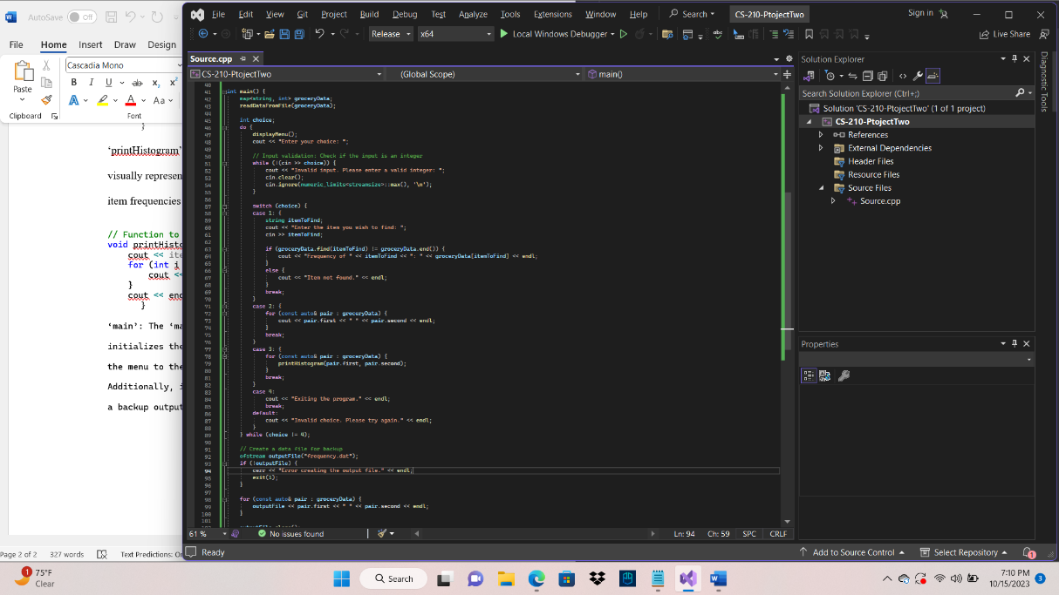

// Create a data file for backup

ofstream outputFile("frequency.dat");

if (!outputFile) {

cerr << "Error creating the output file." << endl;

exit(1);

}

for (const auto& pair : groceryData) {

outputFile << pair.first << " " << pair.second << endl;

}

outputFile.close();

return 0;

}

To utilize the Grocery Tracking Program, users should run it in a C++ development environment, such as Visual Studio. The program relies on the "CS210_Project_Three_Input_File.txt" file for input data. Users can interact with the program by selecting options from the menu to access various functionalities. The Grocery Tracking Program is a powerful tool for the Corner Grocer to analyze customer purchasing trends and optimize its produce section layout effectively. Its well-designed code structure, user-friendly menu, and visual representations of data make it an invaluable asset for data-driven decision-making in the retail environment. Additionally, features like input validation and data backup contribute to the program's robustness and reliability, ensuring the safe handling of crucial data.